Azure ML

1. Azure ML Service > Azure Storage Account > Azure Key Vault > Application Insights > Azure Container Registry
2. Location – east US

VM tier – low priority

VM Size – Standard_DS3_V2

Max Nodes – 1

Idol Seconds – 120 minutes

Name – Test

1. Workspace deployment

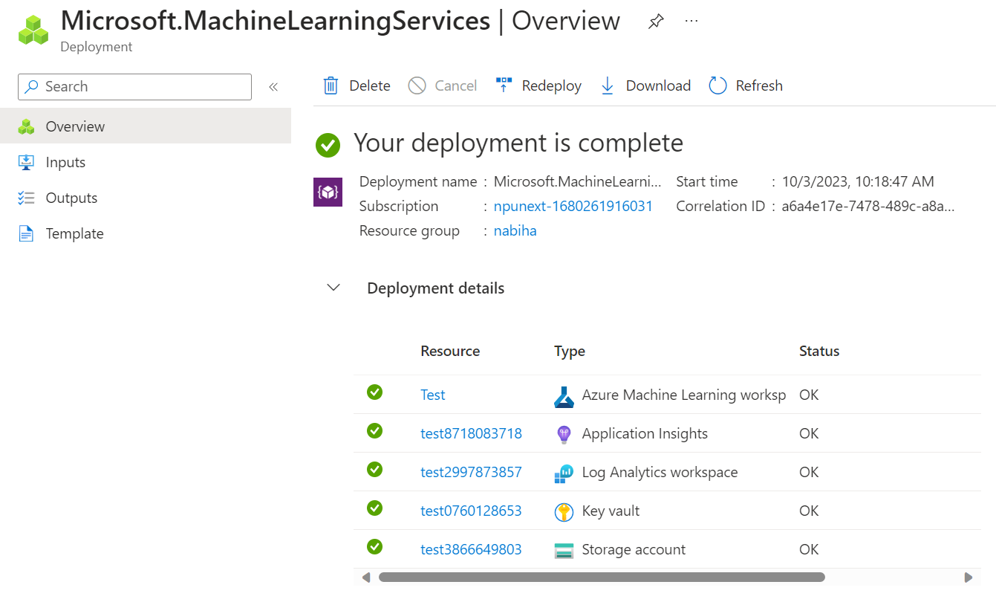

1. Compute instance – compute> new>
2. ML LAB – 01

* Workspace Creation

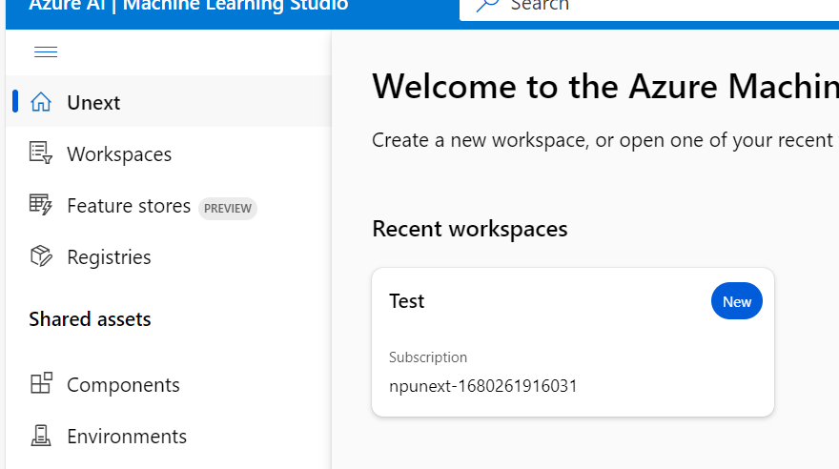

1. Make data available in AzureML

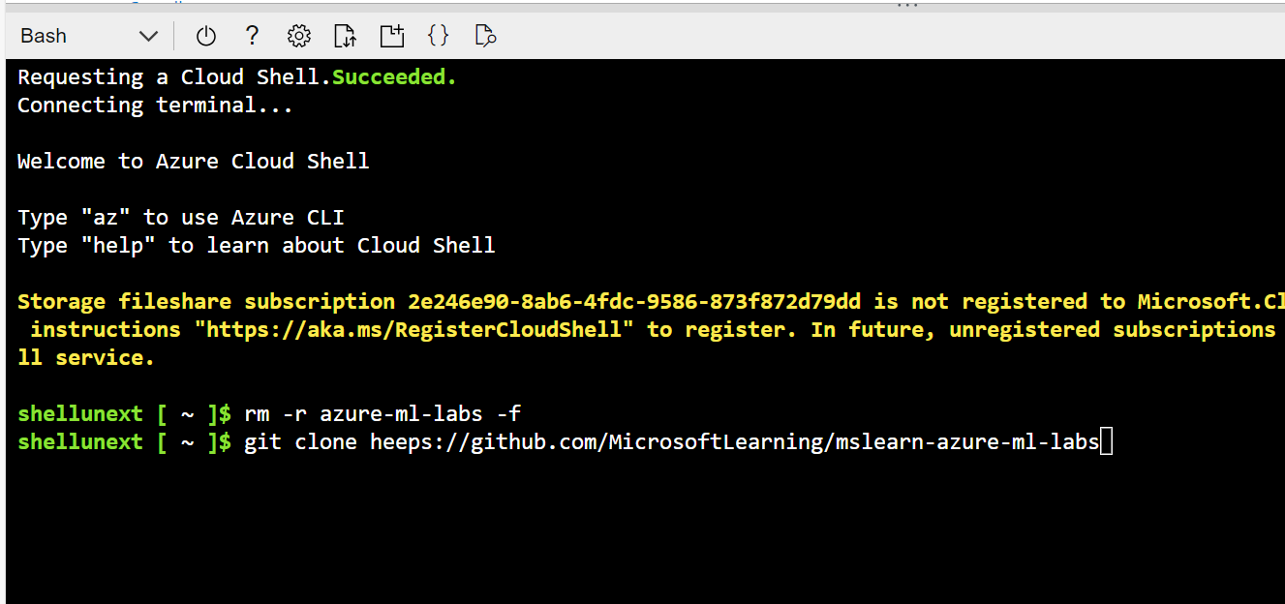

ADF

1. Manage> IR > new> azure self hosted> self hosted> name> >create> IR SETUP> express setup & manual setup> choose

CASE STUDY

**---------------------**

**- Source – extract**

**- Blob Load – (raw)copy activity**

**- Databricks – transform**

**- Select, distinct, SaveAsTable**

**- Staging**

**- Datawarehouse – prepare tables**

**----------------**

**ADF**

1. Sql data warehouse + PowerBi
2. Databricks + PowerBi